**Improving Classification Accuracy with Imbalanced Data in Python**

Let’s get started with the task of performing classification on imbalanced data by importing the necessary Python libraries and the **dataset.**

**import pandas as pd**

**# load the dataset**

**data = pd.read_csv("Insurance claims data.csv")**

**print(data.head())**

**Output:**

**policy_id subscription_length vehicle_age customer_age region_code \  
0 POL045360 9.3 1.2 41 C8   
1 POL016745 8.2 1.8 35 C2   
2 POL007194 9.5 0.2 44 C8   
3 POL018146 5.2 0.4 44 C10   
4 POL049011 10.1 1.0 56 C13   
  
 region_density segment model fuel_type max_torque ... is_brake_assist \  
0 8794 C2 M4 Diesel 250Nm@2750rpm ... Yes   
1 27003 C1 M9 Diesel 200Nm@1750rpm ... No   
2 8794 C2 M4 Diesel 250Nm@2750rpm ... Yes   
3 73430 A M1 CNG 60Nm@3500rpm ... No   
4 5410 B2 M5 Diesel 200Nm@3000rpm ... No   
  
 is_power_door_locks is_central_locking is_power_steering \  
0 Yes Yes Yes   
1 Yes Yes Yes   
2 Yes Yes Yes   
3 No No Yes   
4 Yes Yes Yes   
  
 is_driver_seat_height_adjustable is_day_night_rear_view_mirror is_ecw \  
0 Yes No Yes   
1 Yes Yes Yes   
2 Yes No Yes   
3 No No No   
4 No No Yes   
  
 is_speed_alert ncap_rating claim_status   
0 Yes 3 0   
1 Yes 4 0   
2 Yes 3 0   
3 Yes 0 0   
4 Yes 5 0   
  
[5 rows x 41 columns]**

Let’s have a quick look at the column information and whether the data contains any null values or not:

data.info()

**Output:**

**<class 'pandas.core.frame.DataFrame'>  
RangeIndex: 58592 entries, 0 to 58591  
Data columns (total 41 columns):  
 # Column Non-Null Count Dtype   
--- ------ -------------- -----   
 0 policy_id 58592 non-null object   
 1 subscription_length 58592 non-null float64  
 2 vehicle_age 58592 non-null float64  
 3 customer_age 58592 non-null int64   
 4 region_code 58592 non-null object   
 5 region_density 58592 non-null int64   
 6 segment 58592 non-null object   
 7 model 58592 non-null object   
 8 fuel_type 58592 non-null object   
 9 max_torque 58592 non-null object   
 10 max_power 58592 non-null object   
 11 engine_type 58592 non-null object   
 12 airbags 58592 non-null int64   
 13 is_esc 58592 non-null object   
 14 is_adjustable_steering 58592 non-null object   
 15 is_tpms 58592 non-null object   
 16 is_parking_sensors 58592 non-null object   
 17 is_parking_camera 58592 non-null object   
 18 rear_brakes_type 58592 non-null object   
 19 displacement 58592 non-null int64   
 20 cylinder 58592 non-null int64   
 21 transmission_type 58592 non-null object   
 22 steering_type 58592 non-null object   
 23 turning_radius 58592 non-null float64  
 24 length 58592 non-null int64   
 25 width 58592 non-null int64   
 26 gross_weight 58592 non-null int64   
 27 is_front_fog_lights 58592 non-null object   
 28 is_rear_window_wiper 58592 non-null object   
 29 is_rear_window_washer 58592 non-null object   
 30 is_rear_window_defogger 58592 non-null object   
 31 is_brake_assist 58592 non-null object   
 32 is_power_door_locks 58592 non-null object   
 33 is_central_locking 58592 non-null object   
 34 is_power_steering 58592 non-null object   
 35 is_driver_seat_height_adjustable 58592 non-null object   
 36 is_day_night_rear_view_mirror 58592 non-null object   
 37 is_ecw 58592 non-null object   
 38 is_speed_alert 58592 non-null object   
 39 ncap_rating 58592 non-null int64   
 40 claim_status 58592 non-null int64   
dtypes: float64(3), int64(10), object(28)  
memory usage: 18.3+ MB**

**data.isnull().sum()**

**Output :**

**policy_id 0  
subscription_length 0  
vehicle_age 0  
customer_age 0  
region_code 0  
region_density 0  
segment 0  
model 0  
fuel_type 0  
max_torque 0  
max_power 0  
engine_type 0  
airbags 0  
is_esc 0  
is_adjustable_steering 0  
is_tpms 0  
is_parking_sensors 0  
is_parking_camera 0  
rear_brakes_type 0  
displacement 0  
cylinder 0  
transmission_type 0  
steering_type 0  
turning_radius 0  
length 0  
width 0  
gross_weight 0  
is_front_fog_lights 0  
is_rear_window_wiper 0  
is_rear_window_washer 0  
is_rear_window_defogger 0  
is_brake_assist 0  
is_power_door_locks 0  
is_central_locking 0  
is_power_steering 0  
is_driver_seat_height_adjustable 0  
is_day_night_rear_view_mirror 0  
is_ecw 0  
is_speed_alert 0  
ncap_rating 0  
claim_status 0  
dtype: int64**

The dataset contains 58,592 entries and 41 columns, including the target variable claim_status. It is based on the problem of insurance claim frequency prediction. Here’s a brief overview of some of the features:

* policy_id: Unique identifier for the insurance policy
* subscription_length, vehicle_age, customer_age: Numeric attributes related to the policy, vehicle, and customer
* region_code, segment, model, fuel_type: Categorical attributes representing the region, vehicle segment, model, and fuel type
* max_torque, max_power, engine_type: Specifications of the vehicle’s engine
* airbags, is_esc, is_adjustable_steering: Features related to the vehicle’s safety and convenience
* claim_status: Target variable indicating whether a claim was made (1) or not (0)

Next, I will perform exploratory data analysis to visualize and understand the distributions, relationships, and patterns in the data. It will include examining the distribution of the target variable and key features. Let’s start with visualizing the distribution of the claim_status to understand the class balance:

**import matplotlib.pyplot as plt**

**import seaborn as sns**

**sns.set_style("whitegrid")**

**# plot the distribution of the target variable 'claim_status'**

**plt.figure(figsize=(8, 5))**

**sns.countplot(x='claim_status', data=data)**

**plt.title('Distribution of Claim Status')**

**plt.xlabel('Claim Status')**

**plt.ylabel('Count')**

**plt.show()**

**Output:**

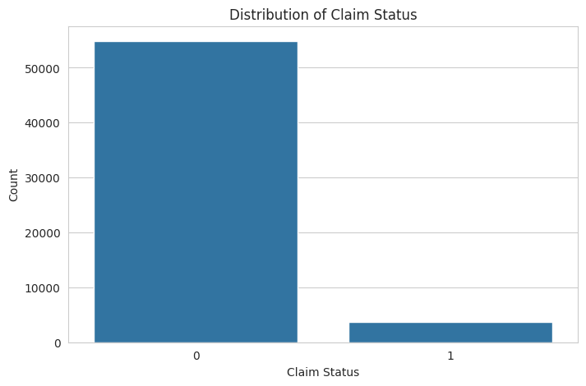

The distribution of the claim_status shows a significant imbalance between the classes, with much fewer claims (1) compared to no claims (0). This imbalance will be a challenge to address during the model training phase to ensure our model does not become biased toward predicting the majority class.

Next, I will perform an analysis of both numerical and categorical features to understand their distributions and relationships with the claim_status. Let’s start by examining the distributions of some key numerical features such as subscription_length, vehicle_age, and customer_age:



1

# selecting numerical columns for analysis

2

numerical_columns = ['subscription_length', 'vehicle_age', 'customer_age']

3

​

4

# plotting distributions of numerical features

5

plt.figure(figsize=(15, 5))

6

for i, column in enumerate(numerical_columns, 1):

7

plt.subplot(1, 3, i)

8

sns.histplot(data[column], bins=30, kde=True)

9

plt.title(f'Distribution of {column}')

10

​

11

plt.tight_layout()

12

plt.show()

**Output:**

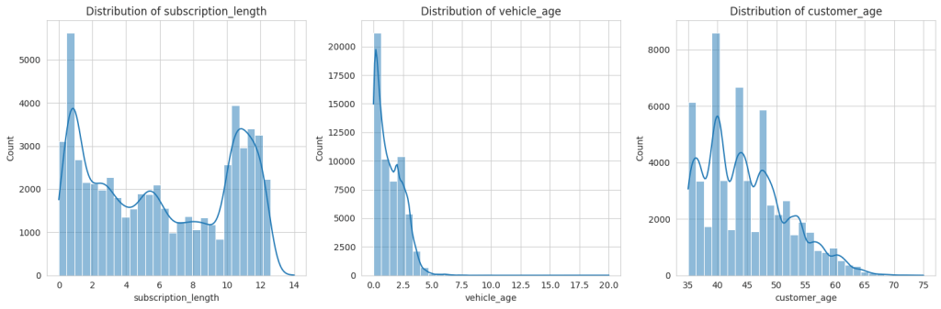

The distributions of the numerical features subscription_length, vehicle_age, and customer_age show the following characteristics:

* subscription_length: Most values are clustered around lower numbers, indicating that many policies have shorter subscription lengths.
* vehicle_age: This distribution is somewhat uniform but with spikes at specific ages, possibly representing common vehicle age intervals in the dataset.
* customer_age: This shows a fairly normal distribution, with the majority of customers falling within a middle-age range.

Next, we will analyze relevant categorical features to understand their variation and relationship with the claim_status. I’ll focus on features like region_code, segment, and fuel_type:



1

# selecting some relevant categorical columns for analysis

2

categorical_columns = ['region_code', 'segment', 'fuel_type']

3

​

4

# plotting distributions of categorical features

5

plt.figure(figsize=(15, 10))

6

for i, column in enumerate(categorical_columns, 1):

7

plt.subplot(3, 1, i)

8

sns.countplot(y=column, data=data, order = data[column].value_counts().index)

9

plt.title(f'Distribution of {column}')

10

plt.xlabel('Count')

11

plt.ylabel(column)

12

​

13

plt.tight_layout()

14

plt.show()

**Output:**

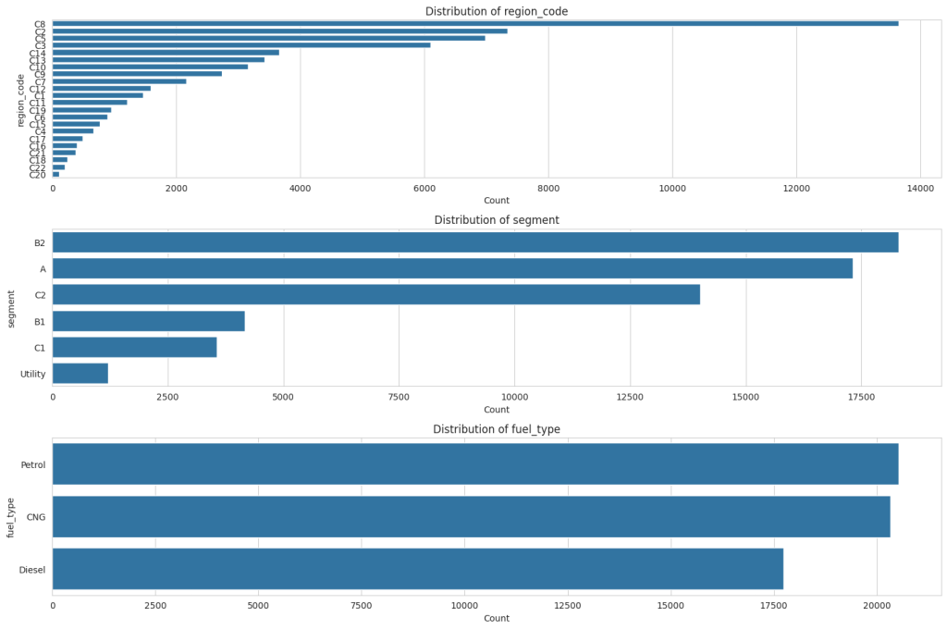

For ‘region_code,’ there is a wide variety of codes, each with varying counts, but a few specific codes dominate with much higher counts than others. In the ‘segment’ distribution, there are fewer categories, with the ‘B2’ segment being the most common, followed by ‘A’ and ‘C2,’ and the ‘Utility’ segment being the least common. Lastly, ‘fuel_type’ shows three categories: ‘Petrol’ has the highest count than CNG and Diesel.

**Handling Class Imbalance**

The next step is to balance the dataset using oversampling to handle the class imbalance observed in the claim_status. Let’s proceed with balancing the classes:

**from sklearn.utils import resample**

**# separate majority and minority classes**

**majority = data[data.claim_status == 0]**

**minority = data[data.claim_status == 1]**

**# oversample the minority class**

**minority_oversampled = resample(minority,**

**replace=True,**

**n_samples=len(majority),**

**random_state=42)**

**# combine majority class with oversampled minority class**

**oversampled_data = pd.concat([majority, minority_oversampled])**

**# check the distribution of undersampled and oversampled datasets**

**oversampled_distribution = oversampled_data.claim_status.value_counts()**

**oversampled_distribution**

**Output:**

**0 54844  
1 54844  
Name: claim_status, dtype: int64**

After performing oversampling on the minority class, both classes are balanced with 54,844 entries each. Now, let’s have a look at some key variables to see what the balanced data looks like:

**# plotting the distribution of 'customer_age', 'vehicle_age', and 'subscription_length' with respect to 'claim_status'**

**plt.figure(figsize=(15, 5))**

**# 'customer_age' distribution**

**plt.subplot(1, 3, 1)**

**sns.histplot(data=oversampled_data, x='customer_age', hue='claim_status', element='step', bins=30)**

**plt.title('Customer Age Distribution')**

**# 'vehicle_age' distribution**

**plt.subplot(1, 3, 2)**

**sns.histplot(data=oversampled_data, x='vehicle_age', hue='claim_status', element='step', bins=30)**

**plt.title('Vehicle Age Distribution')**

**# 'subscription_length' distribution**

**plt.subplot(1, 3, 3)**

**sns.histplot(data=oversampled_data, x='subscription_length', hue='claim_status', element='step', bins=30)**

**plt.title('Subscription Length Distribution')**

**plt.tight_layout()**

**plt.show()**

**Output:**

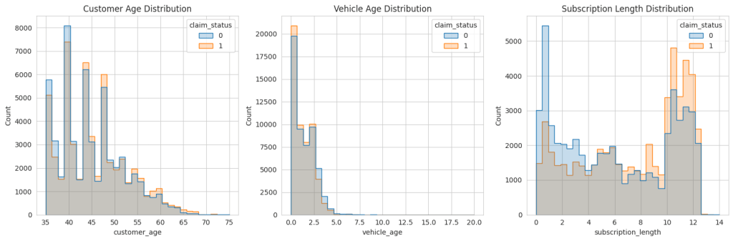

The oversampled data does look like the original data. So, let’s move forward.

#### Feature Selection

Now, we will identify the most important variables for predicting insurance frequency claims. It involves analyzing both categorical and numerical features to determine their impact on the target variable. We will use feature importance techniques suitable for both types of variables.

from sklearn.ensemble import RandomForestClassifier

from sklearn.preprocessing import LabelEncoder

# encode categorical variables

le = LabelEncoder()

encoded_data = data.apply(lambda col: le.fit_transform(col) if col.dtype == 'object' else col)

# separate features and target variable

X = encoded_data.drop('claim_status', axis=1)

y = encoded_data['claim_status']

# create a random forest classifier model

rf_model = RandomForestClassifier(random_state=42)

rf_model.fit(X, y)

# get feature importance

feature_importance = rf_model.feature_importances_

# create a dataframe for visualization of feature importance

features_df = pd.DataFrame({'Feature': X.columns, 'Importance': feature_importance})

features_df = features_df.sort_values(by='Importance', ascending=False)

print(features_df.head(10)) # displaying the top 10 important features

Output:

**Feature Importance  
0 policy_id 0.321072  
1 subscription_length 0.248309  
3 customer_age 0.176639  
2 vehicle_age 0.135190  
5 region_density 0.053838  
4 region_code 0.052649  
7 model 0.000957  
24 length 0.000846  
26 gross_weight 0.000834  
11 engine_type 0.000791**

The top 10 most important variables for predicting insurance frequency claims, according to the Random Forest model, are:

1. policy_id: Unique identifier for the insurance policy
2. subscription_length: Length of the insurance subscription
3. customer_age: Age of the customer
4. vehicle_age: Age of the vehicle
5. region_density: Population density of the region
6. region_code: Code representing the region
7. model: Model of the vehicle
8. engine_type: Type of engine in the vehicle
9. gross_weight: Gross weight of the vehicle
10. length: Length of the vehicle

These variables appear to have the most influence on the likelihood of an insurance claim being made. However, it’s notable that policy_id has a very high importance, which might not be intuitively relevant for prediction. So, we need to make sure to drop the policy_id column while model training.

#### Model Training

The next step is to build a predictive model using the oversampled data. Given the nature of the task (binary classification), a suitable algorithm could be logistic regression, random forest, or gradient boosting. Considering the effectiveness of random forests in handling both numerical and categorical data and their ability to model complex interactions, we’ll proceed with a Random Forest classifier:

from sklearn.model_selection import train_test_split

from sklearn.metrics import classification_report, accuracy_score

from sklearn.ensemble import RandomForestClassifier

# drop 'Policy_id' column from the data

oversampled_data = oversampled_data.drop('policy_id', axis=1)

# prepare the oversampled data

X_oversampled = oversampled_data.drop('claim_status', axis=1)

y_oversampled = oversampled_data['claim_status']

# encoding categorical columns

X_oversampled_encoded = X_oversampled.apply(lambda col: LabelEncoder().fit_transform(col) if col.dtype == 'object' else col)

# splitting the dataset into training and testing sets

X_train, X_test, y_train, y_test = train_test_split(

X_oversampled_encoded, y_oversampled, test_size=0.3, random_state=42)

# create and train the Random Forest model

rf_model_oversampled = RandomForestClassifier(random_state=42)

rf_model_oversampled.fit(X_train, y_train)

# predictions

y_pred = rf_model_oversampled.predict(X_test)

print(classification_report(y_test, y_pred))

Output:

The classification report above provides various metrics to evaluate the performance of the predictive model on the test data. Here’s an interpretation of the results:

1. For class 0 (no claim), precision is 1.00, meaning that when the model predicts no claim, it is correct 100% of the time. For class 1 (claim), precision is 0.98, indicating that when the model predicts a claim, it is correct 98% of the time.
2. For class 0, recall is 0.98, signifying that the model correctly identifies 98% of all actual no-claim instances. For class 1, recall is 1.00, showing that the model correctly identifies 100% of all actual claim instances.
3. The F1-score for both classes is 0.99, indicating a high balance between precision and recall. It means the model is both accurate and reliable in its predictions across both classes.
4. The overall accuracy of the model is 99%, which means that it correctly predicts the claim status for 99% of the cases in the test dataset.
5. The macro average for precision, recall and F1-score is 0.99, reflecting the average performance of the model across both classes without considering the imbalance in class distribution. This high value suggests that the model performs well across both classes. The weighted average for precision, recall, and F1-score is also 0.99, taking into account the imbalance in class distribution. It indicates that, on average, the model performs consistently well across the different classes when considering their distribution in the dataset.

These results indicate a highly effective model for predicting insurance claims, with strong performance metrics across both classes of outcomes. The high recall for claims (class 1) is particularly notable as it implies that the model is very effective at identifying the instances where claims occur, which is often the primary concern in imbalanced datasets.

Now, let’s label the original imbalanced data using our model to see how many instances are correctly classified from our model:

original_encoded = data.drop('policy_id', axis=1).copy()

encoders = {col: LabelEncoder().fit(X_oversampled[col]) for col in X_oversampled.select_dtypes(include=['object']).columns}

for col in original_encoded.select_dtypes(include=['object']).columns:

if col in encoders:

original_encoded[col] = encoders[col].transform(original_encoded[col])

original_encoded_predictions = rf_model_oversampled.predict(original_encoded.drop('claim_status', axis=1))

comparison_df = pd.DataFrame({

'Actual': original_encoded['claim_status'],

'Predicted': original_encoded_predictions

})

print(comparison_df.head(10))

Output:

**Actual Predicted  
0 0 0  
1 0 0  
2 0 0  
3 0 0  
4 0 0  
5 0 0  
6 0 0  
7 0 0  
8 0 0  
9 0 0**

Let’s visualize the percentage of correctly classified and misclassified samples:



1

correctly_classified = (comparison_df['Actual'] == comparison_df['Predicted']).sum()

2

incorrectly_classified = (comparison_df['Actual'] != comparison_df['Predicted']).sum()

3

​

4

classification_counts = [correctly_classified, incorrectly_classified]

5

labels = ['Correctly Classified', 'Misclassified']

6

​

7

# create a pie chart

8

plt.figure(figsize=(8, 8))

9

plt.pie(classification_counts, labels=labels, autopct='%1.1f%%', startangle=140, colors=['#4CAF50', '#FF5733'])

10

plt.title('Classification Accuracy')

11

plt.show()

Output:

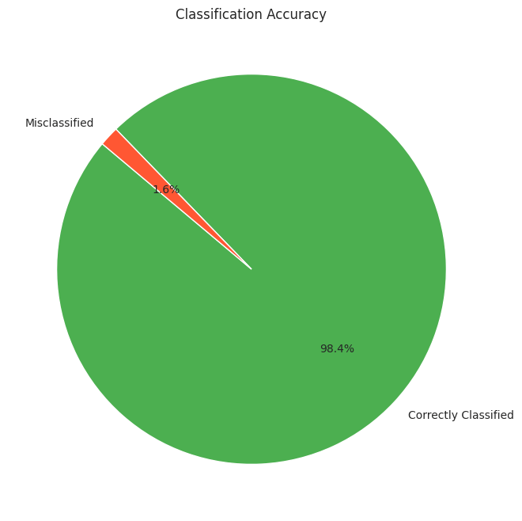

So, we can see that our model performs well on the original imbalanced data as well.

### Summary

So, this is how to handle class imbalance and perform classification on imbalanced data. Imbalanced data refers to a situation in classification problems where the number of observations in each class significantly differs. In such datasets, one class (the majority class) vastly outnumbers the other class (the minority class). This imbalance can lead to biased models that favour the majority class, resulting in poor predictive performance on the minority class, which is often the class of greater interest.